**Group 3**

TOP KEK | Llandinum Bldg, Penglais, Aberystwyth, Dyfed SY23 3DB,

*©Group 3, Aberystwyth University*

Design Document

CS22120 Group Project

# Authors

|  |
| --- |
| Cormac Brady |
| Zach Yewman |
| James Portch |
| Scott Lockett |

Contents

Authors 1

1 Introduction 3

1.1 Purpose of this document 3

1.2 Scope 3

1.3 Objectives 3

2 ARCHITECTURAL DESCRIPTION 4

2.1 Programs in system 4

2.1.1 RPSRrec (Android program) 4

2.1.2 RPSRview (Web Interface) 4

2.1.3 Server (RPSRsrv) 4

2.2 Significant classes 4

2.2.1 RPSRrec (Android program) 4

2.2.2 RPSRview (Web Interface) 4

2.2.3 Server (RPSRsrv) 4

3 Dependency description 6

3.1 Component Diagrams 6

3.1.1 Components Diagram for Web Interface (RPSRview) 6

3.1.2 Components Diagram for Server (RPSRsrv) 6

3.1.3 Components Diagram for Android application (RPSRrec) 7

3.2 Compilation / inheritance dependencies 7

3.2.1 For Android application (RPSRrec) 7

3.2.2 For Server (RPSRsrv) 7

3.2.3 For Web Interface (RPSRview) 7

4 Class interface description 8

4. 1 Android application (RPSRrec) 8

4. 2 For Server (RPSRsrv) 14

5 DETAILED DESIGN 16

5.1 Android application (RPSRrec) 16

5.2 RPSRview (Web Interface) 16

5.3 Server (RPSRsrv) 16

# 1 Introduction

## Purpose of this document

This document describes the outline design for the Software Engineering Group Project 2014 -2015. It should be read taking into account the details of the group project assignment and the group project quality assurance (QA) plan [1].

## Scope

The design specification breaks down the project into separate components and describes the interfaces between those components. It is created according to Requirements Specification SE.QA.RS 2014 -2015 for the group project. References to specific requirements are given in round brackets, e.g. (EIR1). This document is to be read by all members of the team involved in implementation.

## Objectives

The objectives of this document are to:

* Describe the main components of the Reserve Plant Species Recording
* To show the dependencies between components
* To provide details for how each of the main components interface

# 2 ARCHITECTURAL DESCRIPTION

## 2.1 Programs in system

### 2.1.1 RPSRrec (Android program)

The Android Application provides the interface to enable users to make records on the different plant species found in a nature reserve, and then submit that record to a database. This program implements the requirements (FR1), (FR2), (FR3), (FR4), (FR5), and (FR6).

The program will be able to collect multiple plant records and then send the records to the database where it can then be stored, and viewed from the website. It must also be able to use the phones GPS, picture gallery, and camera as methods of getting the users location, and also getting pictures to put into each plant record.

### 2.1.2 RPSRview (Web Interface)

MISSING (NOT POSTED TO GITHUB)

### 2.1.3 Server (RPSRsrv)

MISSING (NOT POSTED TO GITHUB)

## 2.2 Significant classes

### 2.2.1 RPSRrec (Android program)

AddRecord: This will be the class used for adding new records.

SubmitRecord: This will be the method that communicates with the database and sends the records to it.

UserInfo: This will be class that collects the user’s information.

### 2.2.3 Server (RPSRsrv)

MISSING (NOT POSTED TO GITHUB)

# 3 Dependency description

## 3.1 Component Diagrams

### 3.1.1 Components Diagram for Web Interface (RPSRview)

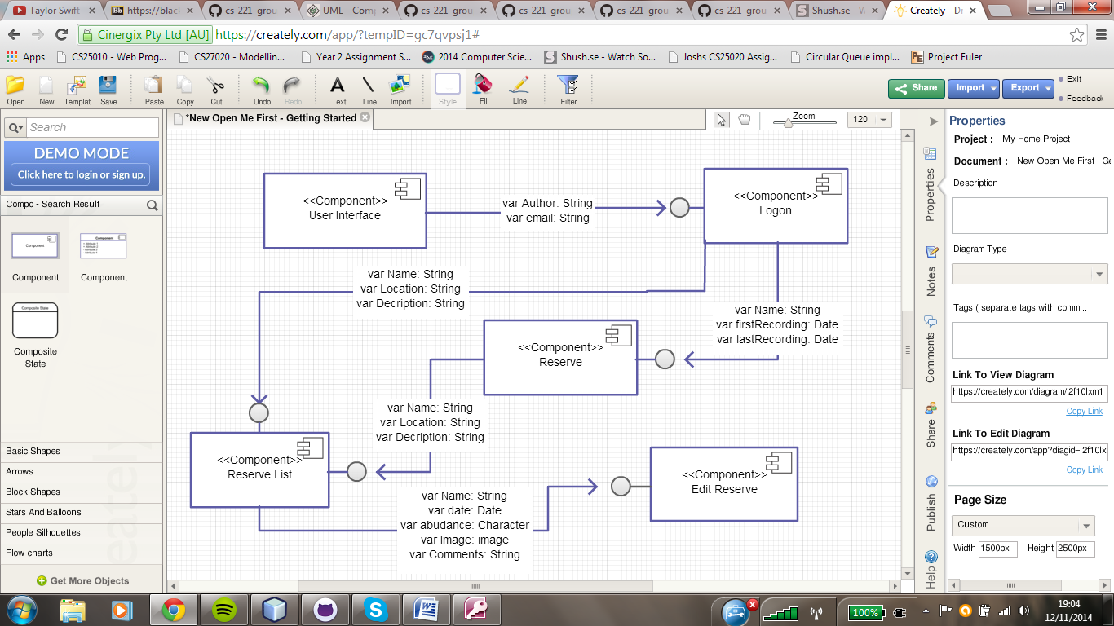

### 3.1.2 Components Diagram for Server (RPSRsrv)

MISSING (NOT POSTED TO GITHUB)

### 3.1.3 Components Diagram for Android application (RPSRrec)

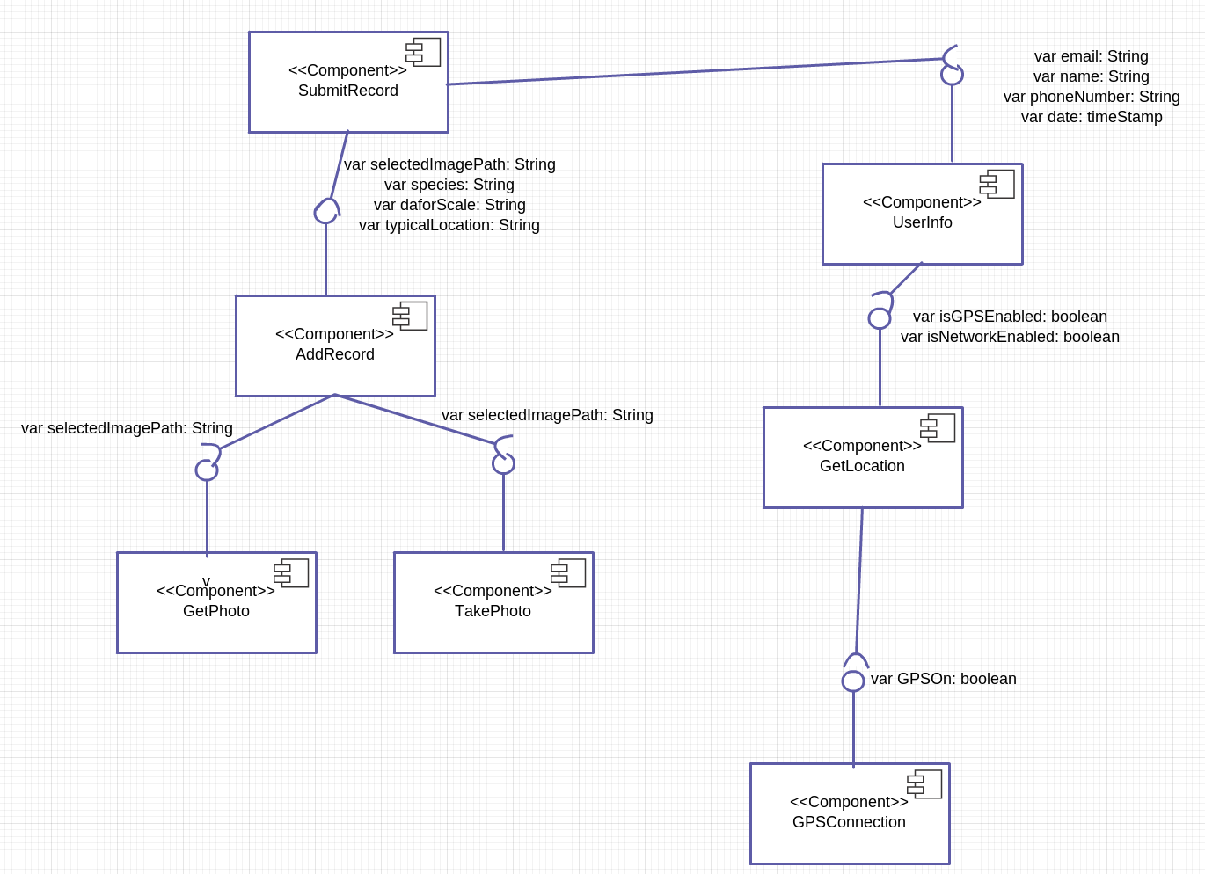

## 3.2 Compilation / inheritance dependencies

### 3.2.1 For Android application (RPSRrec)

“SubmitRecord” depends on “UserInfo” and ”AddRecord”.

### 3.2.2 For Server (RPSRsrv)

MISSING (NOT POSTED TO GITHUB)

### 3.2.3 For Web Interface (RPSRview)

Depends entirely on server methods

# 4 Class interface description

### 4. 1 Android application (RPSRrec)

Public class UserInfo {

private String email, name, phoneNumber;

private final Date timeStamp;

private final Location location;

*/\*\**

*\* Constructor for the user’s information with all the tributes initialised*

*\* @param n name of the user*

*\* @param e email of the us*

*\* @param pm phone number of the user*

*\*/*

public UserInfo( String n, String e, String pn);

*/\*\**

*\* The following getters and setters methods will be used to set variables to the*

*\* users inputs for the fields. The getters methods will then be called when sending*

*\* off the recording session to be used as a label for it*

*\*/*

public void setName(String userName);

public String getName();

public void setEmail(String userEmail);

public String getEmail();

public void setPhoneNumber(String userEmail);

public String getPhoneNumber();

*/\*\**

*\* This method will take a parameter for wether or not the phone has a GPS signal*

*\* and then depending on the answer will get the users location either by their input * or through the GPS*

*\*/*

public void GPSConnection(boolean GPSon);

*/\*\**

*\* This method will return a string containing all of the variables set in this class *aswell as the location of the user. It will then be called from class sending to the * database to add the information to the records.*

*\*/*

public String toString();

}

This class will be used primarily for the app page that asks for the user’s information. When the user inputs them the setter’s methods will set the corresponding variable to the user input which can then be accessed through the getter methods from other classes.

public class AddRecord {

private String species, daforScale, typicalLocation, additionalInfo;

*/\*\**

*\* The constructor for this class*

*\*/*

public addRecord(String s, String ds, String tl, String ai);

*/\*\**

*\* Getter and setter methods for all the variables the user gives from the*

*\* add record page on the app*

*\*/*

public void setSpecies(String speciesName);

public void getSpecies();

public void setdaforScale(String speciesName);

public void getDaforScale();

public void setTypicalLocation(String speciesName);

public void getTypicalLocation();

public void setAdditionalInfo(String speciesName);

public void getAdditionlInfo();

*/\*\**

*\* Get the desired photo of the species and add it to the record*

*\*/*

public void getSpeciesPhoto(File pic);

*/\*\**

*\* Get desired photo of location and add it to the record*

*\*/*

public void getLocationPhoto(File pic);

*/\*\**

*\*This method will return a string containing all of the variables in this class to be*

*\* used when sending the record off to the database.*

*\*/*

public String toString();

}

This class will primarily be used for the app page where the user inputs their record for a species. It will use other classes to get the pictures needed.

public class SubmitRecord {

private String

*/\*\**

*\* This method sends the completed record to the database*

*\* The record will be sent as a Json*

*\*/*

public void sendtoDatabase(ArrayList record);

*/\*\**

*\* This method will try and connect to the database and if it gets a response will*

*\* return true and will start the sending method*

*\*/*

public boolean connectToDatabase();

}

This class will be used to communicate with the server and to send to the database the records. The method “connectToDatabase()” may be better served as a void instead but for now I left it as a Boolean.

public class GetLocation implements LocationListener {

*//GPS status*

public boolean isGPSEnabled = false;

*//network status*

public boolean isNetworkEnabled = false;

*//final check for GPS*

public boolean canGetLocation = false;

*//Attempts to get the users location*

public Location getLocation();

*//Stop using the GPS*

public void stopUsingGPS();

*//function to get latitude*

public double getLatitude();

*//function to get longitude*

public double longitude

public boolean canGetLocation();

}

This class will use the phone GPS to return the coordinates of the user so that they don’t have to input it themselves.

public class GetPhoto extends Activity {

private String selectedImagePath;

*//Choose the picture from the gallery*

public void onCreate(Bundle savedInstanceState);

*//gets the path for the image*

public void onActivityResult(int requestCode, int resultCode, Intent data);

*//helps retrieve the path of the image URI*

public String getPath(Uri uri);

}

This class will be used to access the gallery so that the users can select a picture for the record.

public class TakePhoto extends Activity {

private String selectedImagePath;

*//Called when activity started, takes pictures and stores them*

public void onCreate(Bundle savedInstanceState);

*//gets the path for the image*

public void onActivityResult(int requestCode, int resultCode, Intent data);

}

This is the class that will be used to get a picture straight from the camera and not one that can already be found in the gallery.

### 4. 2 For Server (RPSRsrv)

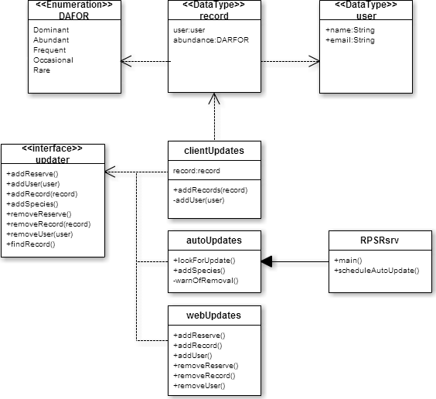



# 5 DETAILED DESIGN

### 5.1 Android application (RPSRrec)

The RSPRrec program is used to record plant records and then send them to the database, so that they can then be picked up and displayed by the website. Some of the difficult parts of this design for the android app include: connecting to, and sending the plant records and user information to the database, and also using the android api to get images from the users phone gallery or taking a new picture using the phone camera, the app will also need to use the api to get the users location from the phone gps.

**Connecting to database:** Connecting to the database and then sending the records to it is all done in the SubmitRecord() class. Within this class are two methods, one that connects to the database, and the other that uses the connection to send the records to the database. The most difficult part of this will be initial connection to the database.

**Using image from Gallery:** Getting an image from the phones gallery is done using the getPhoto() class. Where the gallery needs to be brought up, and then allow the user to select their desired image. Once they have chosen their desired im age the path to that image will then be saved. The hard part of this will be getting loading up the gallery and then getting the path to the selected image.

**Using image from camera:** Taking a picture with the camera, and then getting the images path is done in the TakePhoto() class. This needs to bring up the camera, and then allow the user to take a picture to be used in the plant record. Much like with getting an image from the gallery, the hard part of this function will be to call the camera from the android api and then get the path of the picture that the user takes.

**Using GPS:** Using the GPS in the program is done using the GetLocation() class. The class checks to see if the user has their gps, and network enabled. If they are not enabled then this will be passed to the UserInfo() class where it is used so that a drop down list of locations will come up instead of the GPS location of the user. Within the class is a method by the name of getLocation() that needs to get the users location from the GPS which could prove to be quite difficult.

### 5.2 RPSRview (Web Interface)

MISSING (NOT POSTED TO GITHUB)

### 5.3 Server (RPSRsrv)

The RPSRsrv program is used to receive plant records and enter them into database, so that they can serve to the website (and in a limited scope RPSRrec). A particularly difficult part of this program is the and receiving of the GET POST messages sent from RPSRrec.

**Receiving new records:** This is done in the clientUpdates() class. Within this class are two main methods, one that connects to the database, and the other that uses the connection to receive the GET POST to process and pass into the other method. The most difficult part of this will be initial receiving.

**Updating spices list**: This will routinely get the spreadsheet file from the required website, check if there is a change, if there is it will proceed to add it into the database this will be done from the auto Updates class but secdualing will be done from the main class RPSsrv.

**Viewing/ editing records and adding reserves:** viewing the database from a webpage will be handled from the “webUpdates()” class, the website will invoke methods such as “addReserve()” placing input parameters from fields provided to the user on the page.